

20th December 2018

Dear Parents/Carers,

I can’t believe we are now at the end of the Autumn/Advent term. I want to say thank you to the children, staff and parents for making my first half term so enjoyable. We have achieved so much already, we have raised money for various charities, performed at musical events, competed at numerous sporting events and we have awarded lots of certificates in our celebration assembly that all show what a good school St Thomas More is and how amazing our children are. As we move forward into the Spring/Lent term we have lots to look forward to.

**Staffing**

We are really glad to welcome back Mrs Cummins who will be working part time for 2 days in our Year 3 class. Mrs Davidson will continue to work in Year 3 for 3 days. From February we will welcome back Mrs Ramsell who will take over the 3 days from Mrs Davidson. A huge thank you to Mrs Davidson for her commitment to St Thomas More. We are pleased to say that Mrs Langham will be staying in Year 4/5 until the end of this academic year.

In Foundation stage 2 we would like to say thank you and goodbye to Miss Broome-Faulkner who has been a valued member of the team. After Christmas we are really pleased to welcome back Mrs O’Brien as a teacher in Foundation 2. Mrs O’Brien has been on maternity leave and is coming back to work full time.

We would also like to welcome Mr McWilliams, a new TA who has recently started working in KS2.

**Fundraising**

Thank you to everyone who contributed to our Mission together during Advent, we raised £88. Another huge thank you to everyone who wore a Christmas jumper, we managed to raise £207 for Save the Children.

**Uniform**

Just a reminder about school uniform in case you are buying new things over the holidays. Children should wear black school shoes and NOT boots. During cold weather children can walk to school in boots but must have school shoes to change into.

Bags- children should bring a SMALL bag to school, preferably a book bag for their reading books, letters etc. I appreciate some of the older children do not want book bags but please ensure it is a SMALL rucksack or bag. Our cloakrooms do not have the space for large bags and it can cause a health and safety risk to store them carefully.

**Christmas Dinner**

This was a huge success and the children really enjoyed it. A special thank you to Jan and the team in the kitchen for working so hard to cook an amazing dinner. Also a very special thank you to all of the Friends that helped to make the crackers and helped to serve dinners and tidy up on the day. It is really appreciated by all at school.

**Theatre trip on Friday**

Just a reminder that ALL children will need a **PACKED LUNCH** on Friday.

School will finish at 2.30.

**Christmas Masses**

If you are attending Mass on Christmas Eve or Christmas day at St Thomas More children are invited to dress up as characters from the Nativity scene.

**Monday 24th December**

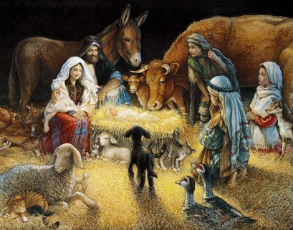5.00pm Vigil Mass, Oadby

6.00pm Vigil Mass, Knighton

9.15pm Carols and Readings

10.00pm Mass

**Tuesday 25th December**

9.00am Mass, Knighton

11.00am Mass, Oadby

**Wednesday 26th December**

10.00am Mass, Knighton

Renewal of Altar Servers commitment for both parishes.

Finally I would like to wish you all a very merry Christmas. May it be a relaxing and peaceful time to spend with family and friends. I hope you all have a wonderful start to 2019 and we will all look forward to seeing you back at school on Tuesday 8th January. I am sure 2019 will be another good year for the children, staff and parents at St Thomas More



God bless,

Mrs Crosse

**Dates for the diary**

|  |  |
| --- | --- |
| Tuesday 8th January 2019 | School opens at 8.40 |
| Thursday 10th January | 10am Whole school Mass |
| Friday 11th January | Year 6 trip to Warning Zone  2.30 Celebration assembly |